**Compositional Gradients – Standard Operating Procedure**

Revised 3 Jan 2022 – Wiley Dunlap-Shohl

Convention for Spray-Coated Gradients:

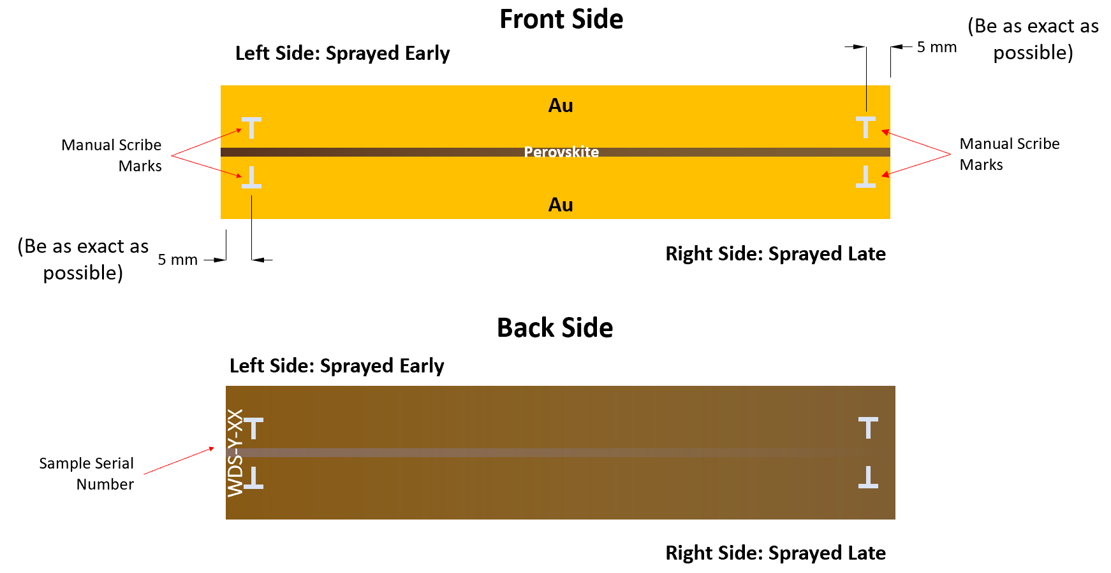

This convention follows simple and intuitive “left-right” logic – that is, that things happening earlier in time are located on the left, and those that happen later are located on the right. Thus, ink is deposited on the left side of the gradient first during spray-coating, and when performing degradation experiments, the leftmost point is measured first. *The left side is identified as the side carrying the sample serial number on the back side*.

1. Configuring the Box and Other Equipment.

This step is only necessary if the box is not set up to do gradients; if the correct objective, stress light, XY stage, and humidifier are all in place, then skip to the next section.

1. Install the objective
   * It is generally best to set up the objective before making the box too crowded with other equipment, as the risk of dropping or otherwise damaging the lens increases with loss of dexterity.
2. Attach the square stress light
   * Do this before installing the stage. Place the light on the circular microscope platform with the power jack facing the right side of the box. Raise the platform as high as it will go, and loft the light into place by loosely suspending it from two screws at opposite corners attached to the box ceiling. Afterward, attach the other two screws.
   * Plug the yellow cable into the right side of the square stress light.
   * Leave the black external power connection slightly undone – it is possible to partially engage the threads so that the leads are mechanically but not electrically connected.
3. Install the XY stage
   * Switch off the Tango controller to the right of the microscope.
   * Place the stage on the circular microscope platform, and secure the set screw using a 5/32” Allen wrench. Make sure the stage is properly secure, but *do not overtighten the set screw*.
   * Attach the X and Y control cables to the right side of the stage. The connections to the stage are loose; avoid putting any torque on them if you can avoid it so that you don’t stress the internal wiring. **(Do not attach or remove the leads if the Tango controller is on – the wires will arc and it may damage them.)**
   * Turn the Tango controller back on.
   * Confirm that the stage is operating properly by driving it with the Tango controller joystick.
4. Set up the humidifier
   * Plug in the power cord to the muffin fan in the near right-hand corner of the box, and ensure that it is pointed at the humid air inlet. The fan is unshielded, so watch your fingers.
   * Fill the blue humidifier tank with water and assemble the humidifier.
   * Seal the connection of the humidifier tank to the base with Parafilm
   * Attach the humidifier tube to the box.
   * Seal the humidifier tub connection at the top of the tank with Parafilm.
5. Replace the 470 kΩ resistor typically used for single samples across the lock-in amplifier leads with a 10 kΩ (?) resistor. Place the 474 kΩ resistor in a safe place.
6. **Software Configuration.**
7. Fill out and run the scripts that generate the “Sample Info” and “Experiment Info” metadata files.
8. Make any necessary changes to the data acquisition program
9. **Loading the Sample on the Stage.**
10. Make sure the heaters and thermocouples are in place
11. Use electrical tape to secure the substrate to the aluminum heating stage.
12. Attach the electrical probes as close to the left edge of the substrate as possible.
13. Drive the XY stage to the right, and lift the sample plate onto it.
14. Carefully drive the XY stage to the left, and place the sample plate in the pocket just to the right of the leaf springs at the near left edge.
15. Slide the sample plate to the left so that it engages with the leaf spring and does not slide around within the XY stage.
16. Tack the sample plate to the XY stage in two places with electrical tape to further impede motion.
17. **Setting up Temperature Control.**
18. Carefully inspect the heating plate: make sure the heaters and thermocouples are securely in place and connected to the controller box, and that the box itself is connected to a power source.
19. Switch on the controller box (left side near the top)
20. Use the up and down arrow keys on the front of the controller panel to adjust the temperature set point; wait for the temperature to equilibrate.
    * Due to the relatively narrow conductive path between the heaters and the thermocouples, the heaters will usually overshoot the set point by a substantial margin. Therefore, it is wise to bump the set point up in increments rather than setting the desired temperature all at once. For example, if you wish to set the plate at 65 °C, choose a set point of 45 °C first, wait for the temperature to stabilize, and then adjust to the final values of 65 °C. Judging from recent experience, the plate will hit 65 °C not long after being set to 45 °C. If there is any doubt, be conservative and adjust the temperature slowly!
21. **Be very careful to avoid setting the temperature too high. Never operate the system without the thermocouples in place, or the heaters could set something on fire!**
22. **Programming the XYZ stage analysis path.**

This portion requires some speed and skill, particularly when working at higher temperatures due to thermal expansion of the heating stage. Three points are generally necessary to properly prepare the software to keep its position and focus at all points along the gradient: the start, end, and the midpoint.

1. Once the temperature has stabilized, focus the sample at the starting point (indicated by the left scribe marks) and use the Stoddard_getStagePos.bsh script to note the X, Y, and Z coordinates.
   * Note that temperature excursions may lead to some fluctuation of the Z height/focus; the autofocus is generally pretty good at taking care of this. For the Z coordinate, just do your best to choose a good value and the autofocus will do the rest.
2. Focus at the end point (indicated by the right scribe marks) and note the coordinates as above
3. Use the find_midpoint.bsh (?) script to navigate to the intermediate point. Adjust the stage as necessary to center (X,Y) and focus (Z) the channel, and save the X, Y, and Z coordinates using Stoddard_getStagePos.bsh as before.
4. Input the start, middle, and end coordinates into the control software script.
5. **Positioning the Photodiode.**
6. Place the transmittance measurement photodiode underneath the sample stage, as close as possible to the bottom without contacting it. Confirm that there is no interference over the range of travel of the substrate by driving the stage across the entire span of the gradient(s) you intend to measure. Make sure that readings are able to be taken by comparing photodiode readings with the filter cube on and off of position 3.

**G. Setting up Humidity Control.**

1. Change the day and night set points on the humidity controller to the desired RH percentage.
2. Close the front door to the box, and seal any remaining major gaps.
3. Turn on the power knob to the humidifier. (Note: this knob controls the amount of power sent to the ultrasonic transducer in the humidifier; the humidity controller is a simple ON/OFF mechanism that switches the controller on when the reading is 5% below the set point and off when it is 5% above. Different power settings on the humidifier knob are appropriate for reducing excursions about different set points – for instance, you would want a higher power setting if the set point is 85%, and a lower one if it is 40%).
4. Ensure that the system is working properly, and make adjustments to the power knob as necessary to reduce humidity fluctuations.

**H. Setting up Illumination Control.**

1. Turn the knob on the yellow power cable to the desired setting (usually the maximum available)
2. When ready to start the run, fully engage the black external power connection to turn on the light.

**I. Start the Run.**

1. Press the “play” icon in the Python console to execute the data acquisition script; check to make sure that everything is proceeding normally.

**Checklist Before Starting the Experiment**

* “Sample Info” metadata file created
* “Experiment Info” metadata file created
* Gradient is at the correct temperature
* Start, middle, and end (X,Y,Z) coordinates are set
* Correct resistor is in place, and the right resistance is set in Python code
* Correct probe and soak light intensity settings are set
* MicroManager is off
* Filter cube set to position 3
* Box air line is connected and purging
* Gas cylinder has adequate pressure until the next time someone will be in lab to check it
* Humidifier is operational and set to the desired humidity level
* Gas purge and humidifier are working to keep RH at the correct level
* Square stress light is on and turned to the correct intensity